LOCALIZATION INSIGHT PORTAL

1. Screen to capture WSR Data (Issues and Accomplishments, metrics and next Week priority)

* You can capture data for a week that can be entered only by Logged-in user for a particular product.

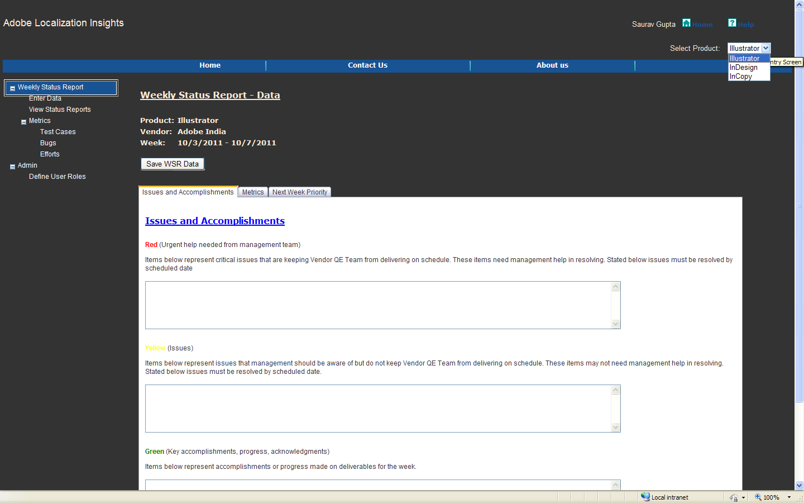

1. Screen to view compiled Status Report data

* You can compile/view data for all vendors or for a particular vendor
* You can view data for a week or for a month

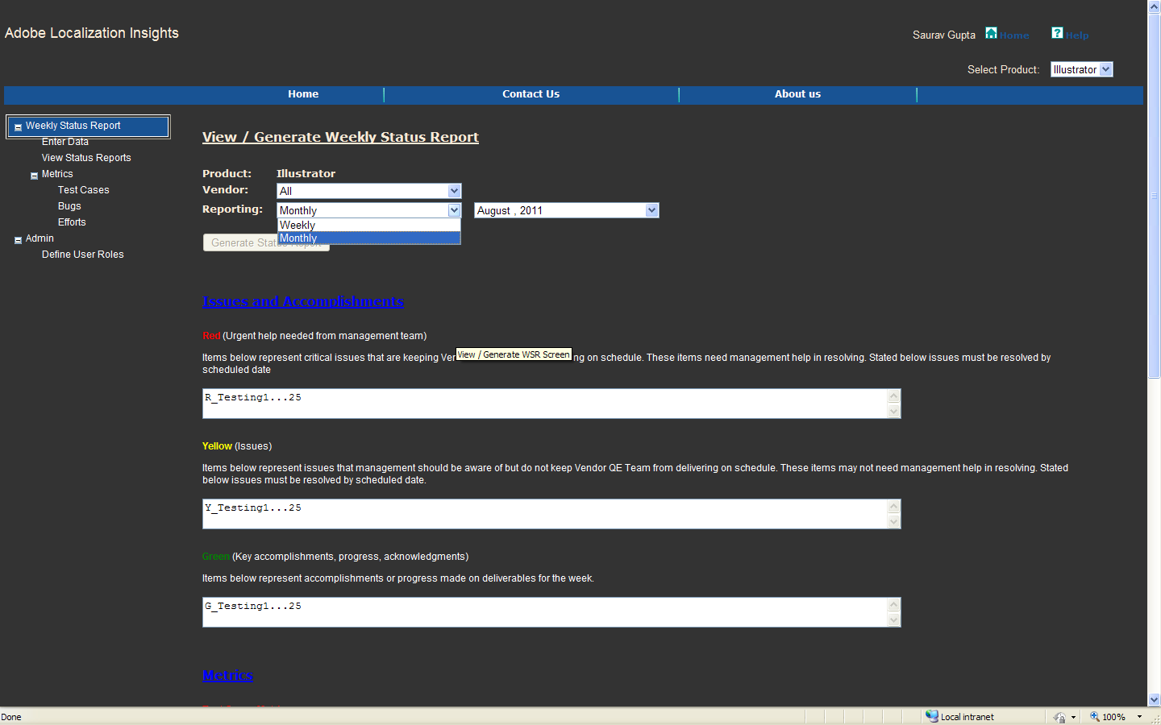

1. Screen to generate Metrics Report

* You can generate report to compare data for different products
* You can generate report to compare date across vendors a particular product.
* You can select products and Vendors

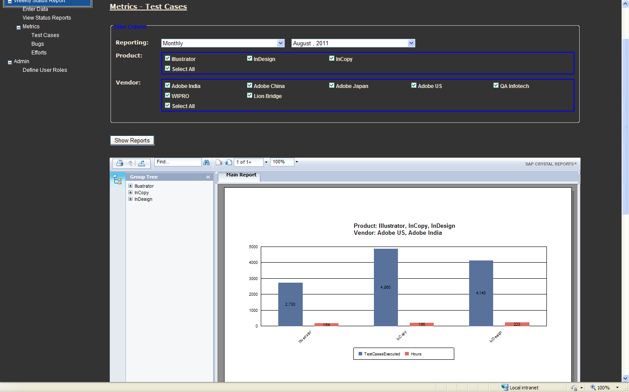

1. Screen to define user access so that only few can have access to view compiled status report and generate Metrics.

* You can associate a user to vendor and product.
* You can define access to user to access different sections of portal
* You give different access to different users.

